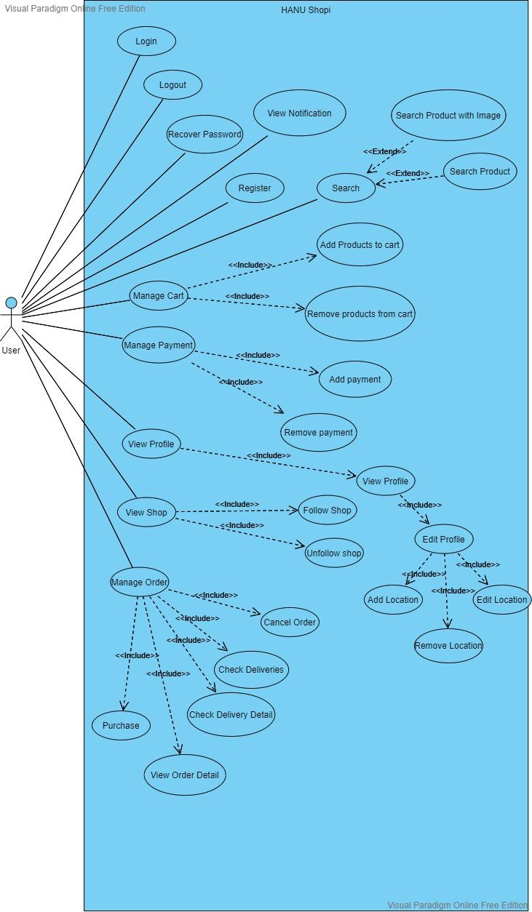

Visual Paradigm Online Free Edition

HANU Shopi

Login

Logout

(Recover Password

View Notification

Register

Search

Add Products to cart

<<Extend> Manage Cart).

<<Extend>>

Remove products from cart Manage Payment

<<Extend>>

Add payment

<<Extend>>

Remove payment

View Profile

<<Extend>>

Edit Profile

View Shop

---> Follow Shop <<Extend>>

<<Extend>

(Unfollow shop)

Manage Ordes ------->

<<Extend>>>Delete Order

elete Order

**<<Extends**

**<<Extend>>**

Update Order

**<<Extend><Exterid>**

Order Product

View Order Detail

Check Order

Visual Paradigm Online Free Edition